RT5350F-OlinuXino Getting started manual v1.1
by Maarten van Druten
Version 1.1 (28-3-2017)
License: GNU General Public License v3.0

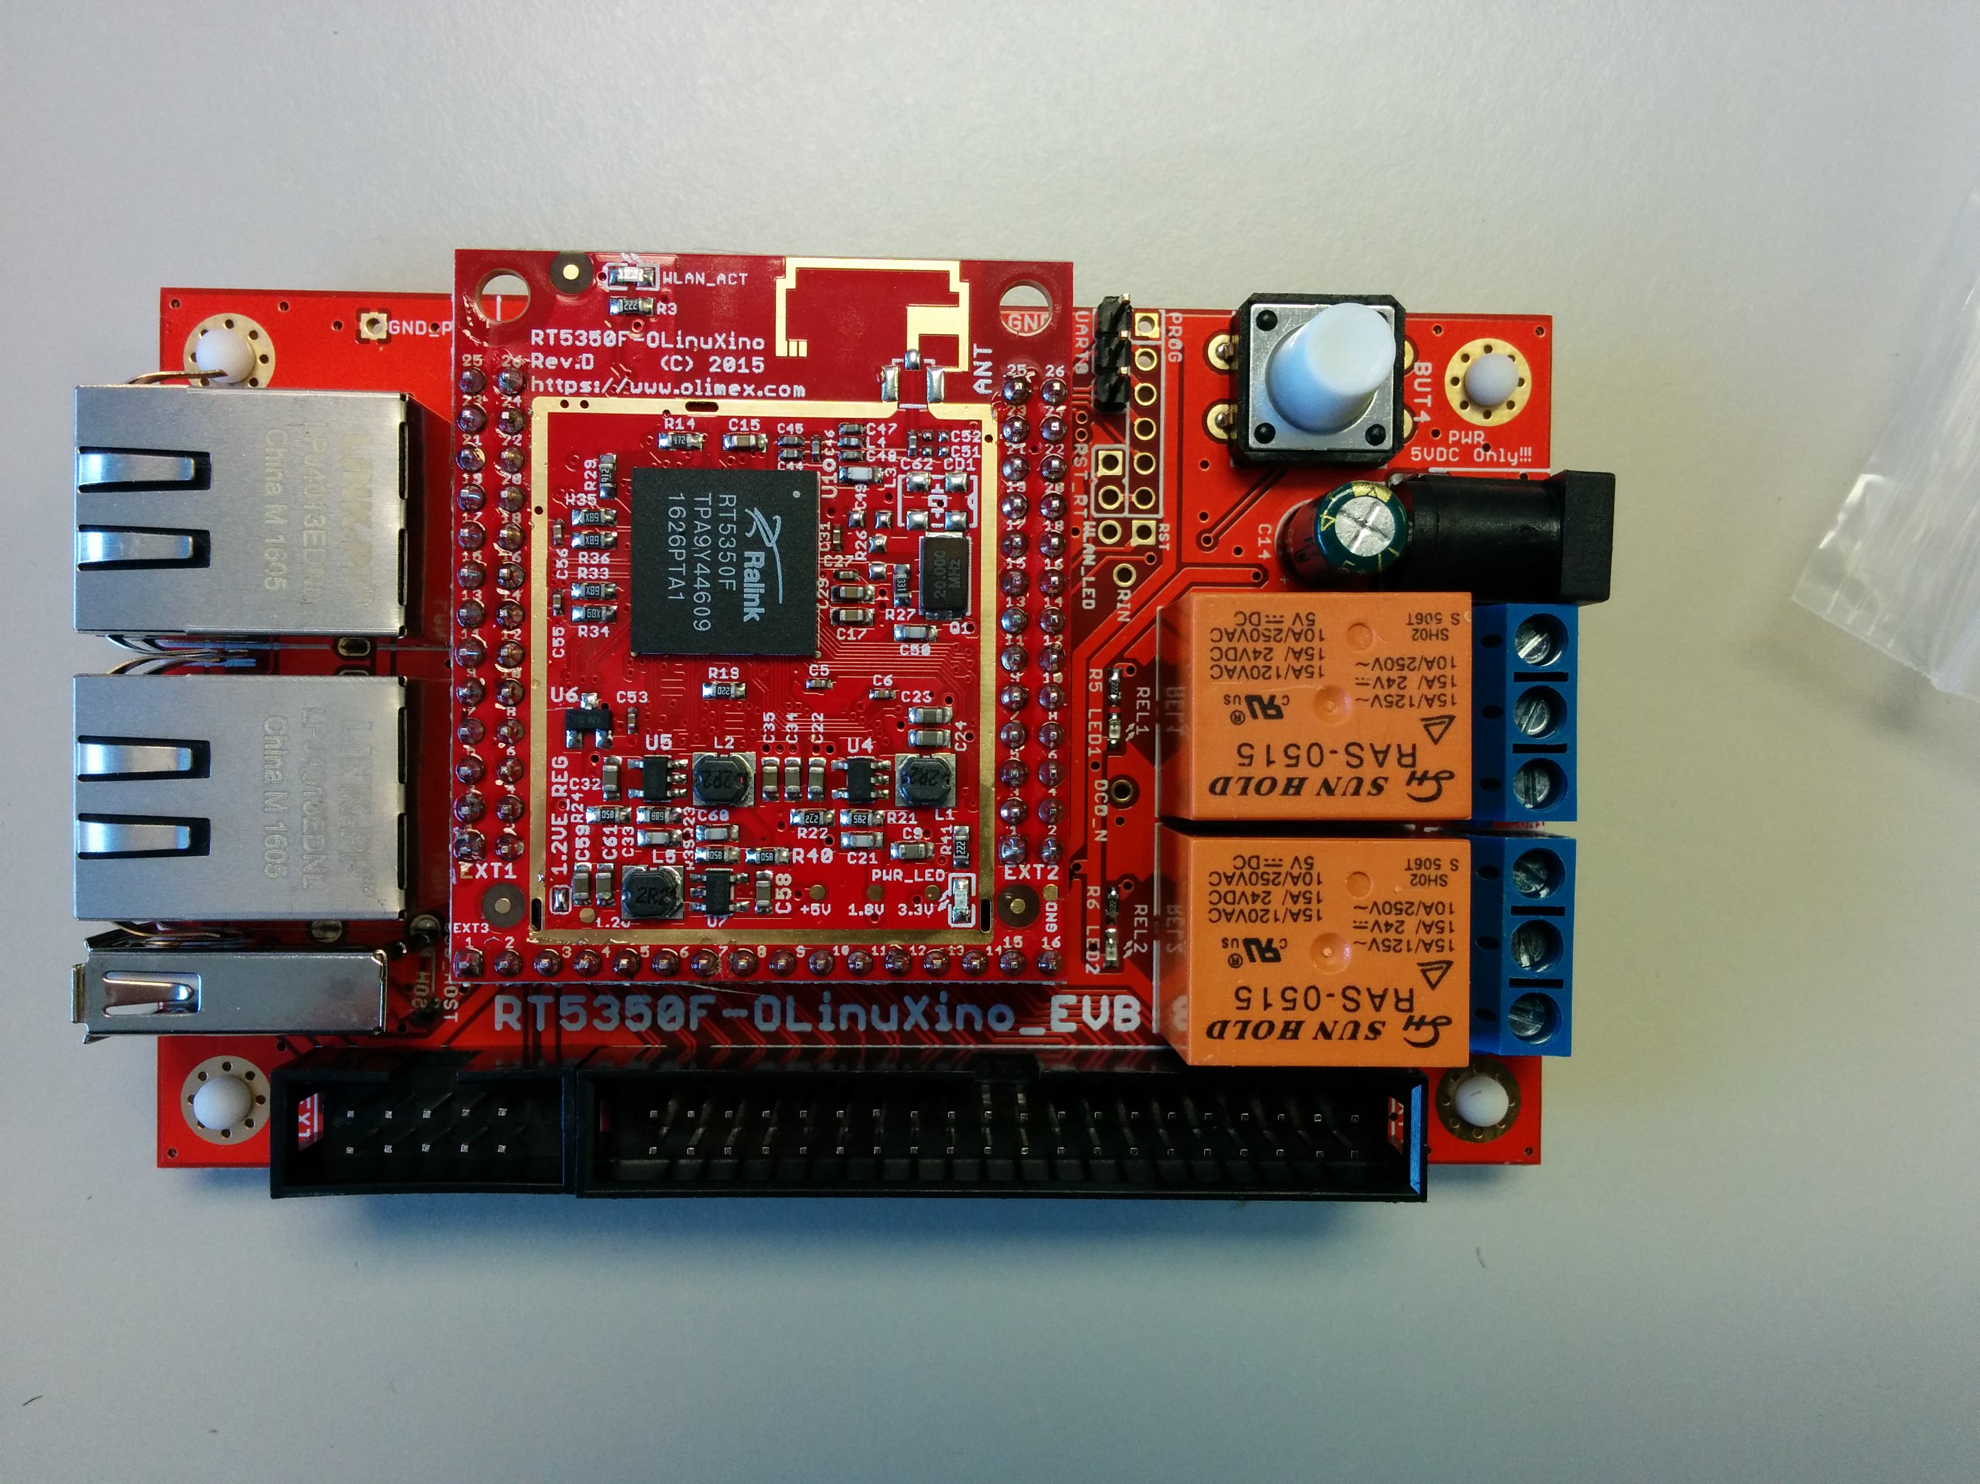

Note this board is 5V only, so use a proper power supply.
This manual is intended for starters that have no or less experience with Olimex or other development boards.

How-to connect the “USB-Serial-Cable-F” to the RT5350F-OlinuXino board?

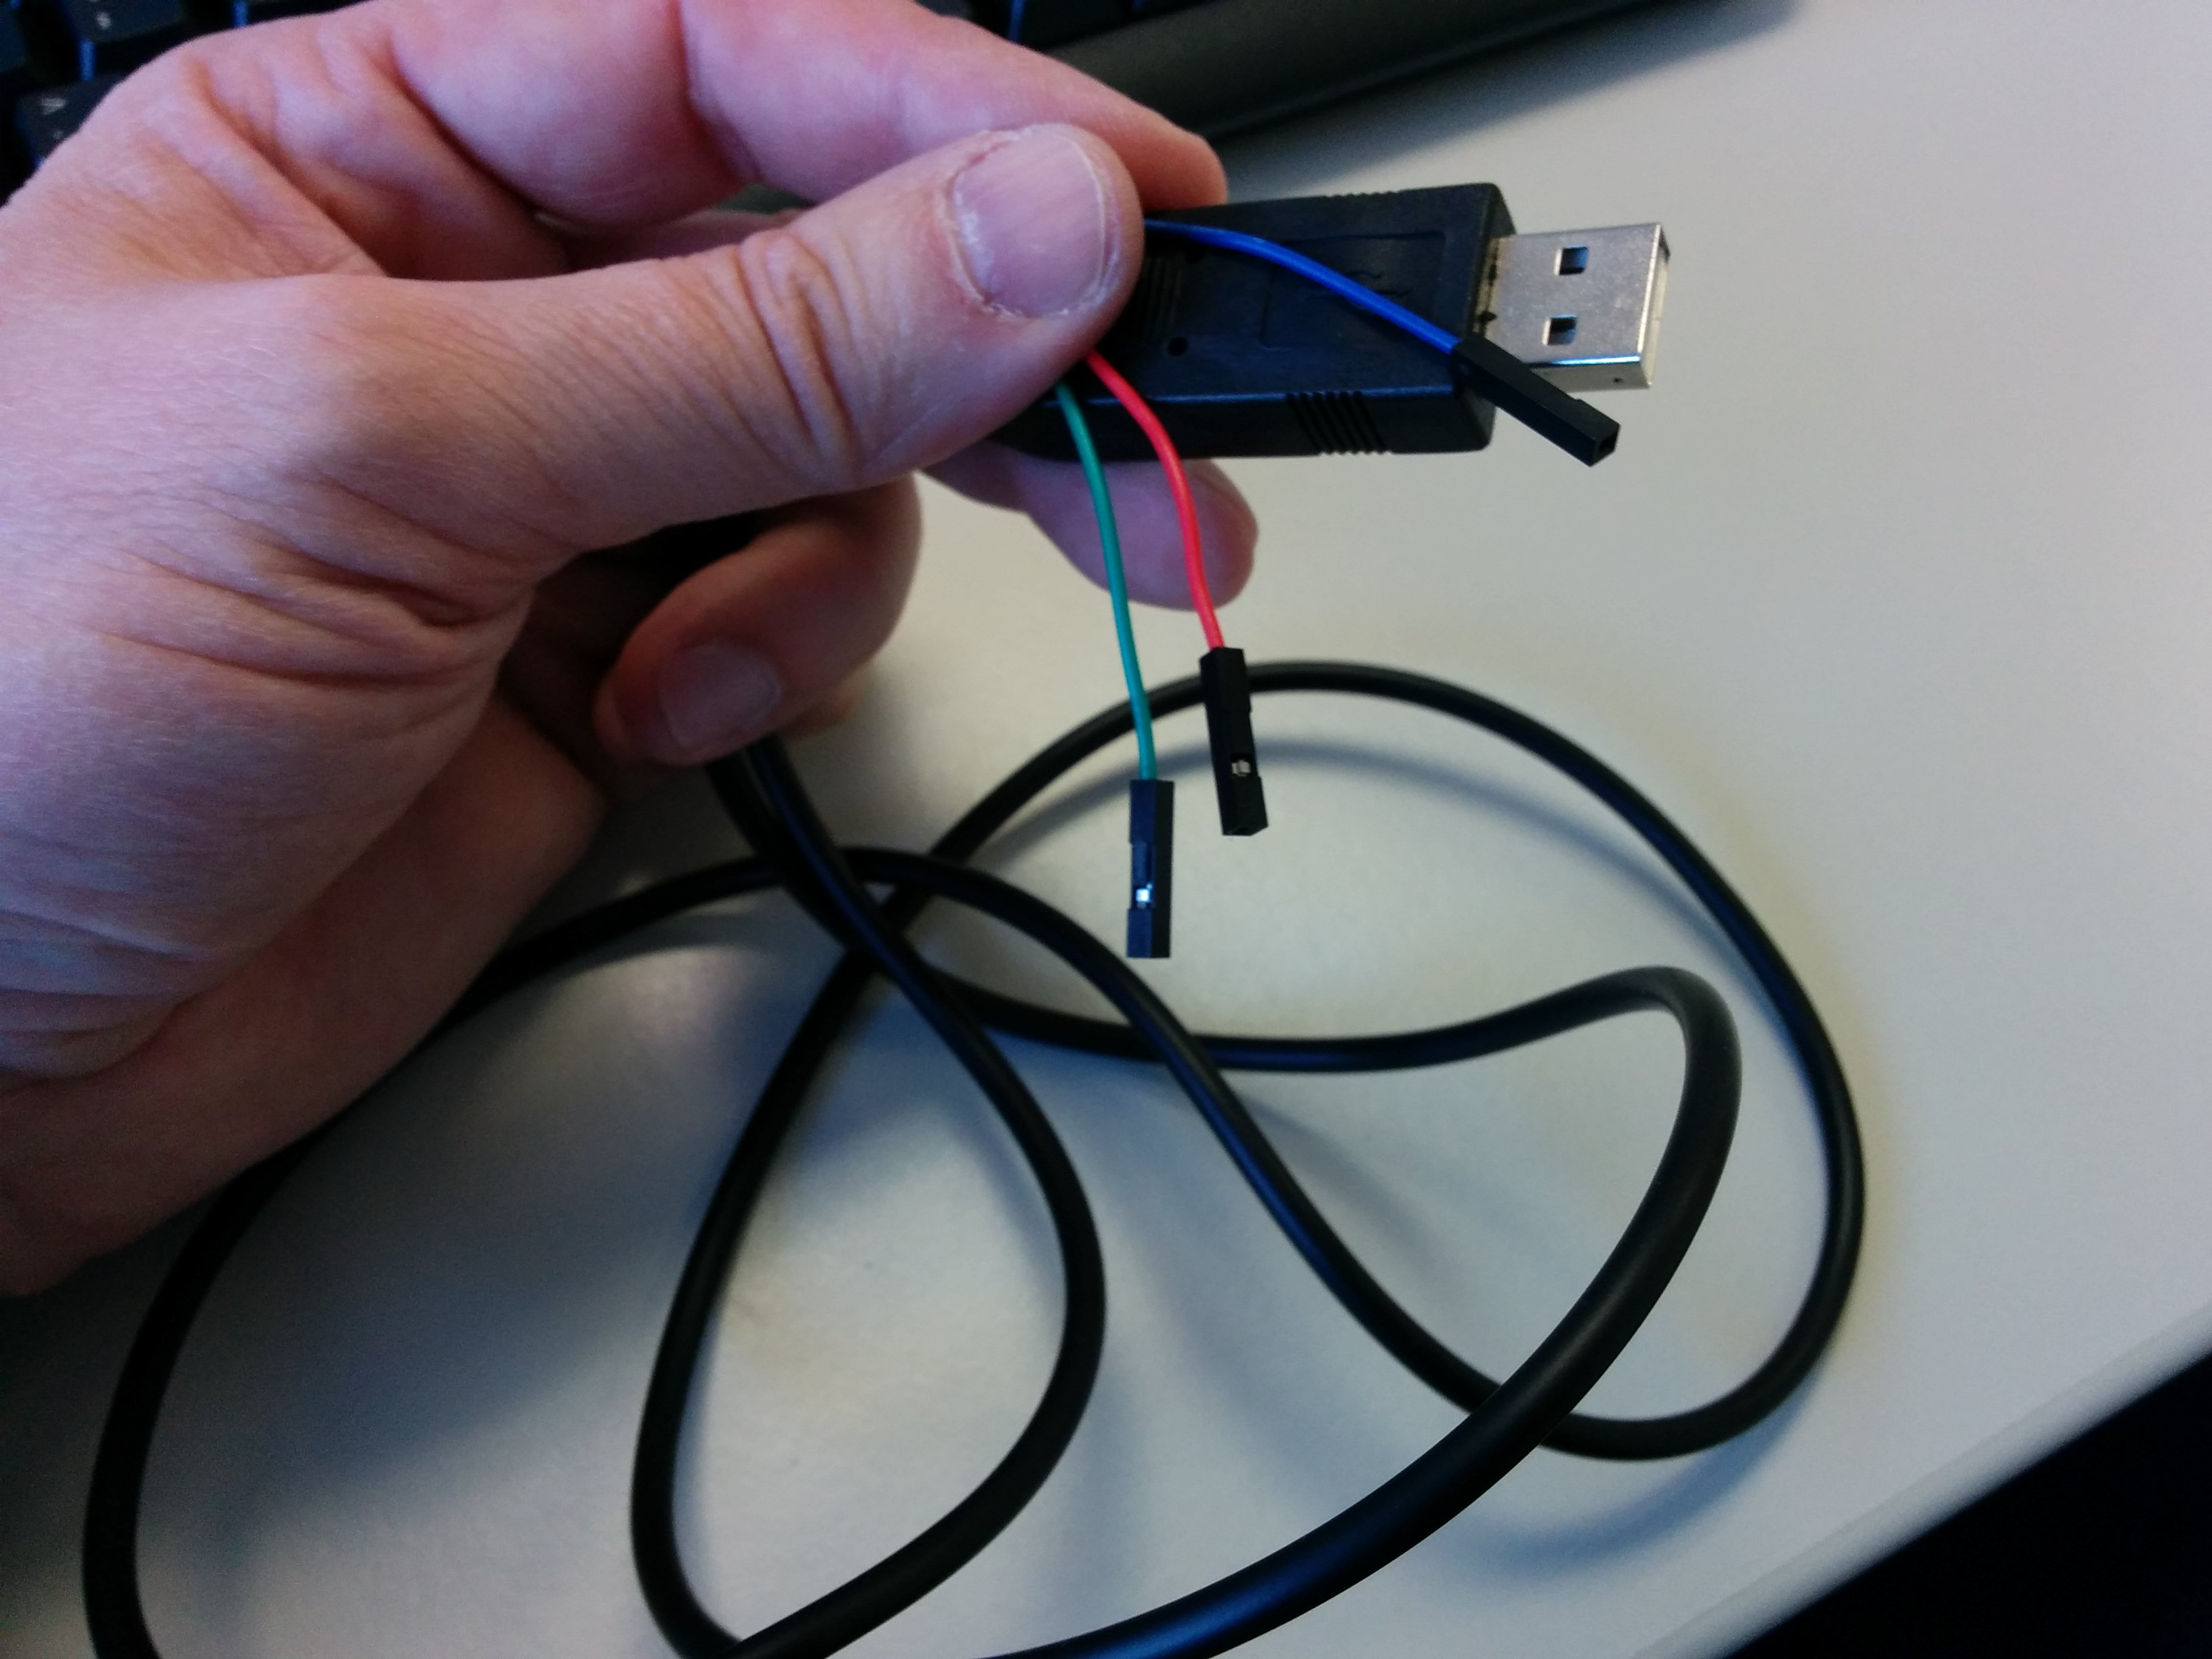

On the cable the colors are:
BLUE = GND
RED = TX (OUTPUT)
GREEN = RX (INPUT)

But they are going to connected differently onto the board!

Connecting the Olimex “USB-Serial-Cable-F” to the board:
The RX line of the cable (GREEN wire) should go to TX line of the target board,
the TX line of the cable (RED wire) should go to the RX line of the target board.
The BLUE wire should go to the target's GND line.

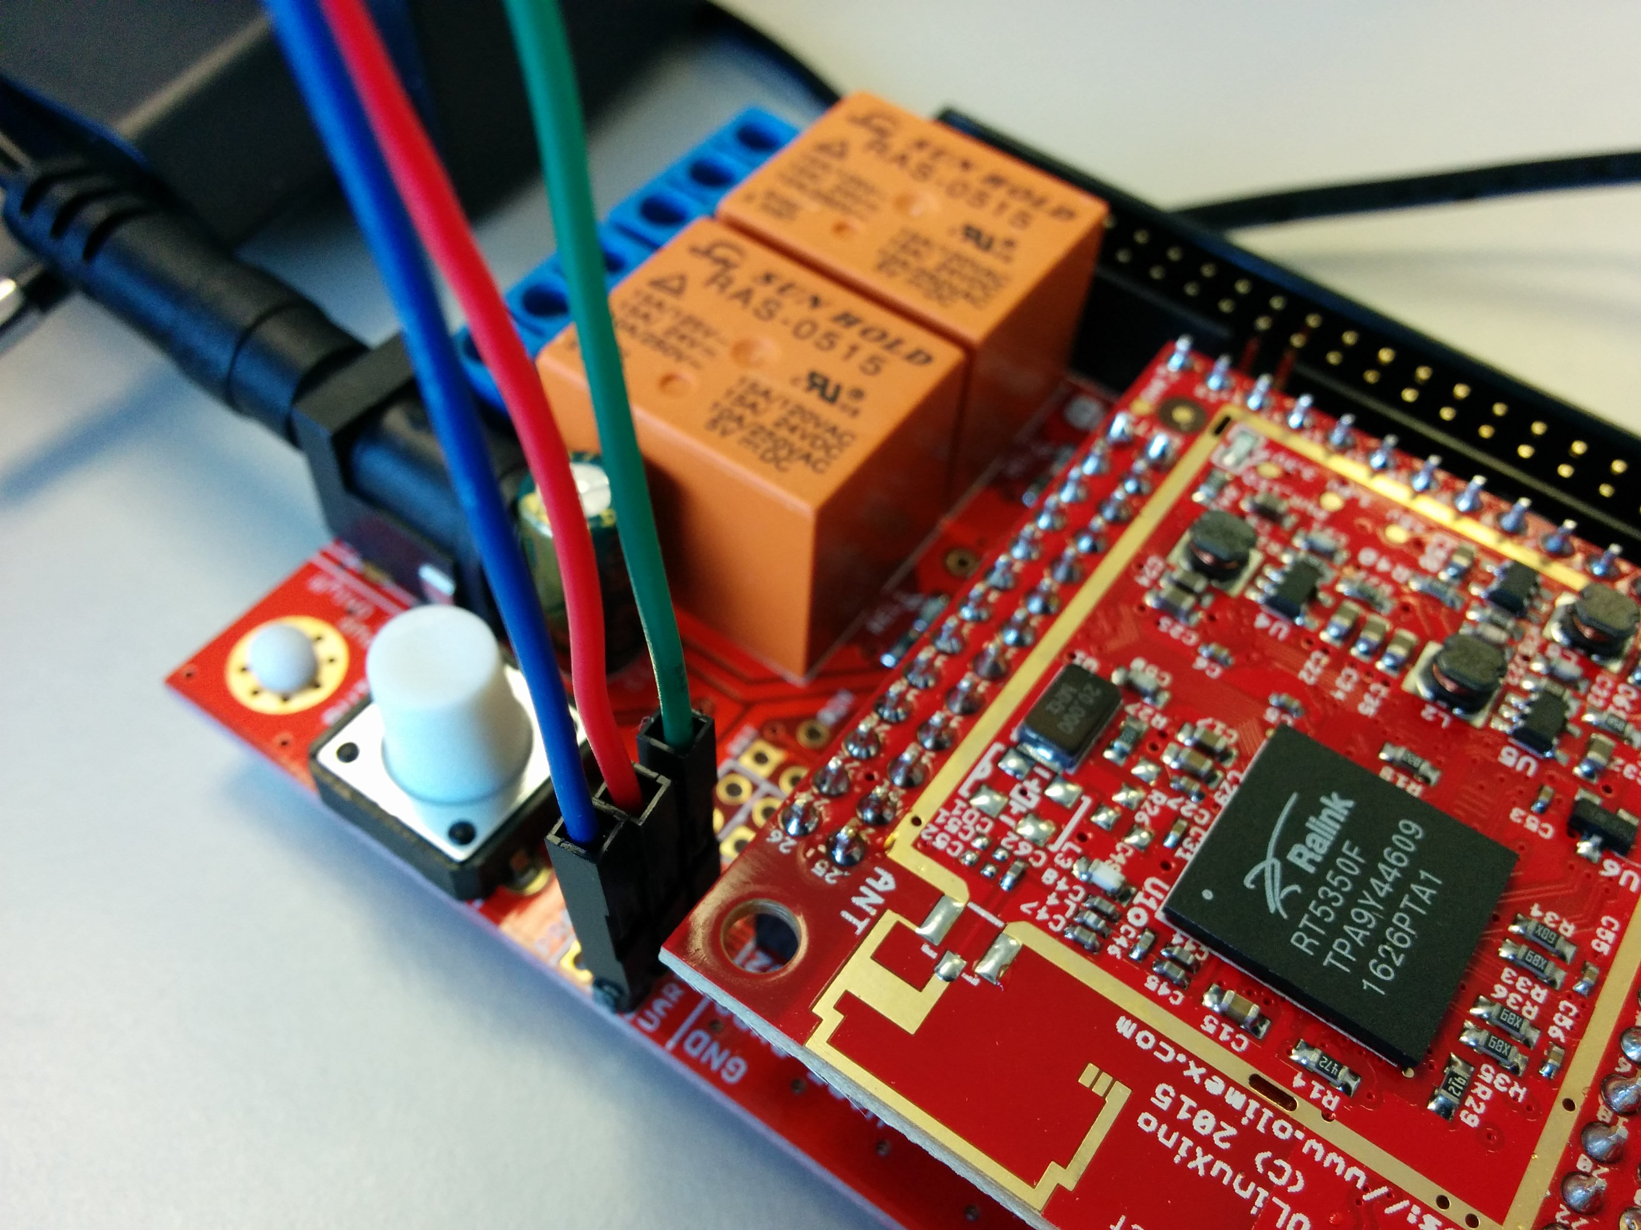

I'm going to connect the cable to a laptop that has Ubuntu 14.04 LTS OS installed

Before we can connect to the device with the USB-serial cable, we first have to install a program on Ubuntu 14.04 called “Screen”

Installation of “Screen ”

Install screen by running the following command:

sudo apt-get install screen
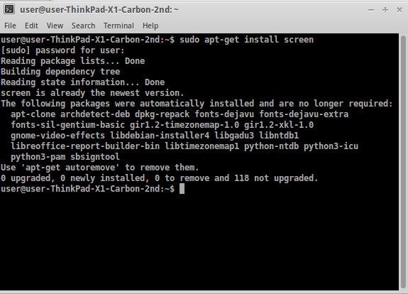

To verify that screen has been installed, type: screen -v
and you will see something similar to Screen version 4.02.01 (GNU) 28-Apr-14. You can also run which screen and it will show /usr/bin/screen.

Connect the cable to the board, open an terminal and type:

dmesg |grep USB

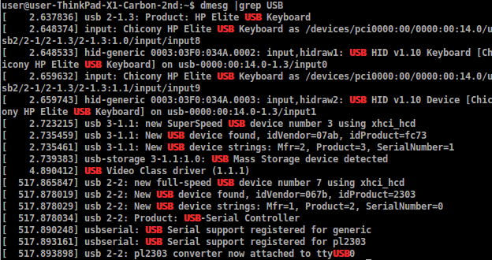
Now you can verify on which “tty” your Olimex device is connected

In the terminal you can see the connection has been made on ttyUSB0

[ 517.865847] usb 2-2: new full-speed USB device number 7 using xhci_hcd
[ 517.878019] usb 2-2: New USB device found, idVendor=067b, idProduct=2303
[ 517.878029] usb 2-2: New USB device strings: Mfr=1, Product=2, SerialNumber=0
[ 517.878034] usb 2-2: Product: USB-Serial Controller
[ 517.890248] usbserial: USB Serial support registered for generic
[ 517.893161] usbserial: USB Serial support registered for pl2303
[ 517.893898] usb 2-2: pl2303 converter now attached to ttyUSB0

No type:

sudo screen /dev/ttyUSB0 57600

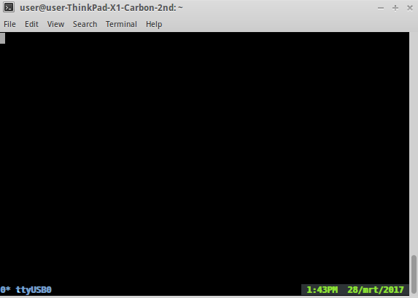

Then power on the board by plugging in the power adapter

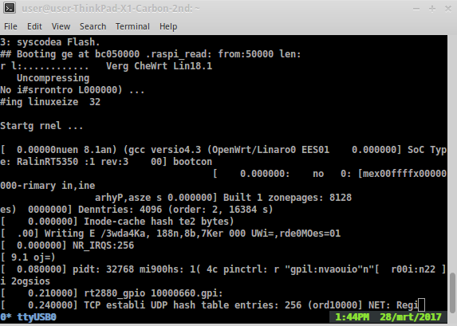

this can take some time

press enter

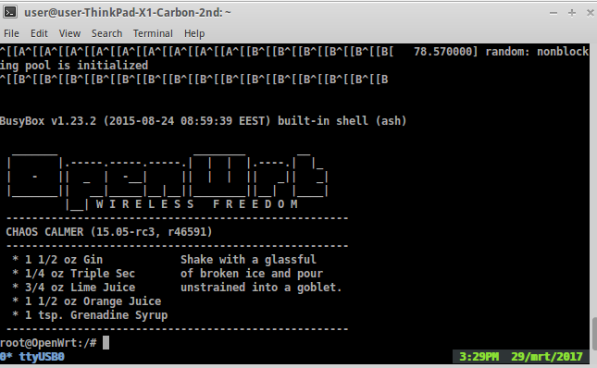

Now you can configure your Olimex RT5350F with your web browser: 192.168.1.1
First we are going to change the root password
Type: passwd

And type your new root password two times
Advise: use long passwords containing: random letters, numbers and special characters)

Tip: don't write down this password on any digital media,put write it down in your physical small personal “password/contacts” book.

Configuring your Olimex RT5350F with the web GUI:

Go in your web browser to the ip address of your Olimex RT5350F
In this example it is: 192.168.1.1

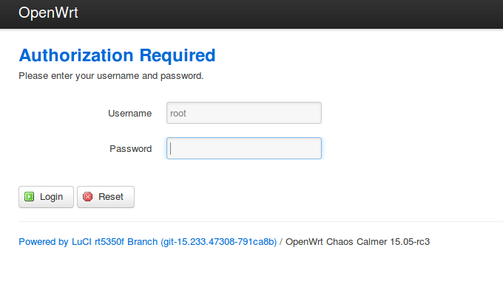

Login with your root password

Part 2 --------------------------------------------------------------------------------------------------------------

How to configure mesh networking on Open WRT
...we need still more info about what protocol and which configuration is the best suited for a globally compatible open wifi mesh network...

To manage the routing we need to install additional software:
We are going to use the “B.A.T.M.A.N” mesh protocol because of the following advantages:

- Protocol Agnostic (IPv4 / IPv6 / IPX / Apple talk...)
- Devices don't even need an IP Address.
- Clients can't roam
- Self building, healing and scaling
- Can have a gateway nominated to get out of the mesh.

Option 1: Installing the “B.A.T.M.A.N” software using the OpenWRT Web-GUI:

Login into your router with web-browser (for example: 192.168.1.1)

Go to – “System” - “Software”

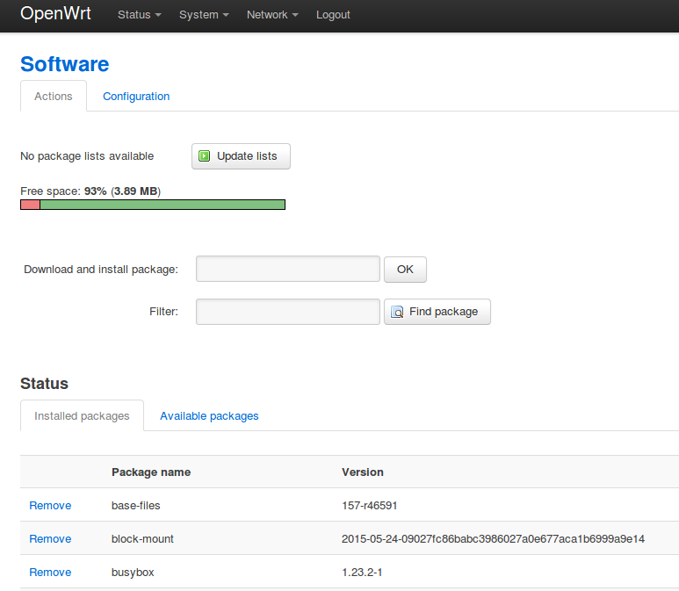

Update the list

Go to “Available packages” and select the letter “B”

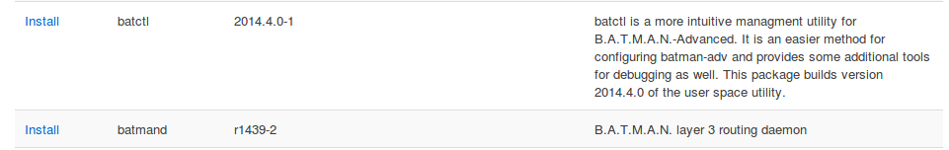

Here you select and install the B.A.T.M.A.N packages

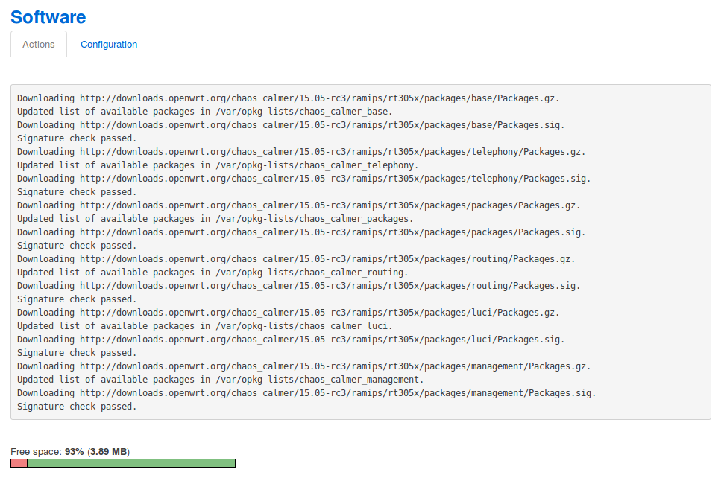

Option 2: Installing the software in a terminal:

first update the channel:
opkg update

Then install “B.A.T.M.A.N”
opkg install kmod-batman-adv

Part 3 --------------------------------------------------------------------------------------------------------------

How to add and external antenna”

Order this part:
http://nl.mouser.com/ProductDetail/Taoglas/RECE-20279-001E-01/?qs=sGAEpiMZZMuLQf%252bEuFsOrpgOsj5KQw0bE3BaRHpHVVw%3d

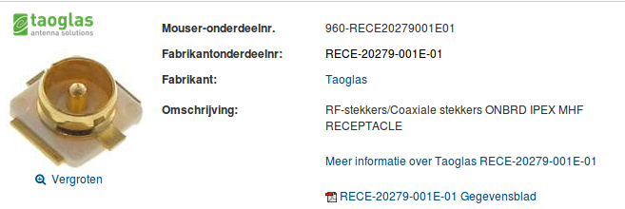

and solder it on the board (see photo)

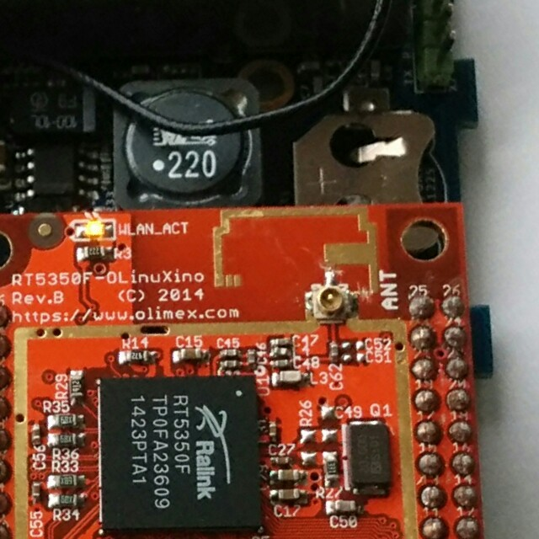

You see we have cut through the two lines from the antenna.

